SimSelf: An Introduction to Water Quality and Water Pollution for the North Carolina 8th Grade Science Curriculum
The content for this document was designed to teach two of the North Carolina Common Core Essential Standards for 8th Grade Science:
8.E.1.3: Predict the safety and potability of water supplies in NC based on physical, chemical and biological factors including temperature, dissolved oxygen, pH, nitrates and phosphates, turbidity, and bioindicators.
8.E.1.4: Conclude that the good health of humans requires: Monitoring of the hydrosphere, Water quality standards, Methods of water treatment, Maintaining safe water quality and Stewardship.
The details contained in these lessons are based on the NCDPI “Unpacking the Content” document for this unit. Portions of the text were taken directly from the NCDPI Unpacking the Content document.
Author:
Gail S. Powell, Ph.D.
National Board Certified Teacher
2004 Kenan Fellow, NCSU
East Cary Middle School
Wake County Public Schools
Cary, NC

Chapter 1. Fresh Water Pollution

Why Should I Care about Water Pollution?
Water is essential to all life on Earth. Clean water is important to the survival of mankind. It affects human activities such as agriculture, fishing and recreation. It impacts the health of our society and our ecosystems. When the quality of water in an aquatic ecosystem is good, the ecosystem will support many different types of plants and animals. Should the same ecosystem become polluted, the community of plants and animals living there will decline in numbers and diversity.
NC’s coasts and rivers shape the behavior and life cycles of the plants and animals that live there. If chemicals, hazardous wastes, oil etc., collect on the ground surface they can contaminate ground water and surface waters. Pollutants such as urban and agricultural runoff and industrial inputs can impact all aquatic organisms. As the environment degrades, the diversity of organisms living in that community will decrease. Species that can tolerate more pollution will survive. More sensitive species will die out.

Water Quality
Water quality is a term used to describe the chemical, physical and biological characteristics of water. Potable water is water that is safe to drink. Safe water is water suitable for bathing or cleaning. In this unit, you will learn how safe and drinkable the water is in and around North Carolina.
Natural forces and human activities are constantly influencing water quality. Fresh water lakes, rivers and groundwater are the source of our drinking water. Testing for the presence of chemicals and other factors that can influence water quality such as nutrients, industrial pollutants and pesticides in water is important. This is a normal part of ensuring public health (science of promoting human health and prolonging human life) and stewardship (protection of natural resources). We need to be aware of the contaminants in our water to ensure that our water is safe.

Sources of Water Pollution
For centuries humans have disposed of human, industrial and solid wastes in streams, rivers and oceans. As the human population grows we will produce more: toxic waste, excess nutrients* from fertilizers*, manure*, leaking septic tanks* and sewage* treatment plants. As it enters our waters, chemical and environmental changes will occur in our waters and ecosystems. These changes will create a change in the animal and plant communities that live in these waters. They may have economic impacts on NC’s fishing, tourism, agriculture and other industries as well as public health. If we allow our water to become polluted, we will jeopardize the future of all these industries which so many North Carolinians rely on for their income. Unsafe water can lead to human health problems.
*nutrients: substances that make plants grow
*fertilizer: a form of nutrients applied by farmers to make plants grow
*manure: solid waste from animals
*septic tanks: used in rural areas to treat human waste
*sewage: water containing human waste

What is Water Pollution?
Water pollution is the addition of any substance that has a negative effect on water quality or the living things in it. Pollution can contaminate surface water, ground water or rain water. Water can become contaminated by microorganisms, toxic chemicals, metals, radioactive waste, agricultural waste, industrial waste, human sewage, petroleum products and litter.
What happened in the 1950s and 60s that increased our awareness of the importance and dangers of releasing chemicals into the environment? In the 1950s, an insecticide called DDT was introduced and widely used by American farmers for the control of insect pests on their crops. Rachel Carson, an American scientist studied the impact of DDT on our ecosystems. In 1962, she published a book called Silent Spring. It increased worldwide awareness of the environmental impact of widespread use of DDT. She questioned whether it was smart to apply large amounts of chemicals into the environment without understanding their possible effects on ecosystems and human health.
DDT is a lipophilic chemical. Lipophilic means “fat loving”. Lipophilic chemicals tend to accumulate in the fat of animals that consume them in their diet. They also persist in the environment for a very long time. Because of the widespread use of DDT across the United States for many years, humans and animals in our ecosystems began to accumulate DDT in their body fat. In a food chain, the amount of DDT that accumulates in body fat increases as you move up the food chain to the top predators. Predatory birds were particularly exposed to DDT and accumulated high concentrations of DDT in their body fat. View these two videos (https://www.youtube.com/watch?v=DxqDaTUh08o and https://www.youtube.com/watch?v=xI2M97Gl5qM) to learn more about DDT, biomagnification and bioaccumulation in the food chain.
PCBs like DDT, are another lipophilic chemical that accumulates in food chains. PCBs were common in industrial waste since the early 1900's. PCBs cause cancer and other health effects. In the US, PCBs were banned in 1979 because they are so persistent in the environment and because they bioaccumulate. Watch the video segment "What Warning Signals Does Nature Give Us?" about PCBs from the Frontline video Poisoned Waters.

Rachel Carson
Rachel Carson named her book Silent Spring because she saw bird populations declining in numbers across the US. It turns out that high concentrations of DDT in predatory birds such as the Bald Eagle, Brown Pelican, Peregrine Falcon and many other species of birds caused egg shell thinning. Parent birds accidentally crushed the thin shelled eggs while incubating them in the nest. Very few chicks hatched and survived because of the thin egg shells. In the 1960s, many top predatory birds including our national bird, the Bald Eagle, were on the verge of extinction because of DDT.

Figure 1. Rachel Carson, author of Silent Spring.
From http://www.inspirationhouse.org/2012/09/23/silent-spring-turns-50
Figure 2. Some predatory birds harmed by DDT.
Bald Eagle from http://en.wikipedia.org/wiki/Bald_eagle
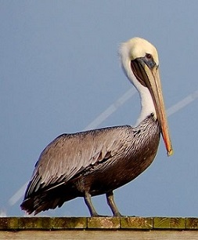
Brown Pelican from http://www.allaboutbirds.org/guide/brown_pelican/id
Peregrine Falcon from http://www.arkive.org/peregrine-falcon/falco-peregrinus/image-G140483.html
Silent Spring created the birth of the environmental movement in the US. It increased public and political awareness of the risks associated with indiscriminate use of chemicals in the environment. Largely because of the heightened environmental awareness created by Rachel Carson’s book, our country created the U. S. Environmental Protection Agency (EPA) in 1970. Its initial focus was to ensure that pesticides that are sold in the US will not be harmful to humans or the environment. Since 1970, the purpose of the EPA has expanded to protect human health and the environment. EPA does this by writing and enforcing regulations based on laws passed by Congress. Today, EPA is responsible for ensuring the safety of our water, air, drinking water and protecting endangered species as well as pesticide regulation.

Four Major Types of Water Pollution

Human Waste
There are four major types of water pollution:
1. Human waste
2. Industrial waste (Point Source)
3. Storm water runoff (Non Point Source) (includes farm and urban waste)
4. Litter
In 1854, a doctor in London, England, John Snow, was treating patients for cholera in a poor neighborhood in London. Cholera is a disease caused by a bacteria that is spread through contact with human waste. Many people had died. Dr. Snow discovered that all of his infected patients got their drinking water from a well that was near a sewage pipe. The sewage had contaminated the well water with cholera bacteria. He ended the epidemic by closing the well. This discovery taught us the importance of keeping human waste away from our drinking water sources. Today, in developed countries around the world, we have wastewater treatment systems that carry human waste to treatment plants where it is cleaned and disinfected before being released back into the environment.

Industrial Waste (Point Source Pollution)
Industrial waste is waste discharged from factories and power plants into the environment. Industrial pollution is usually a type of Point Source Pollution. Point source pollution is linked to a specific source (Ex. a pipe, a smoke stack etc. This type of pollution is fairly easy to control. The person responsible for discharging the waste has responsibility for the waste and must obey related pollution laws and regulations.)
There are three main types of industrial waste:
a. Chemical waste discharged into rivers: Some factory waste is discharged directly into a waterway via a pipe from the factory. A company must have a government permit to discharge waste into a river or stream. In the past, some factories dumped or spilled chemical waste onto the ground at their factory sites. Years later, we are still finding evidence of this bad practice. Watch this video segment on industrial pollution from the Frontline video Poisoned Waters.
Figures 4a and 4b. Examples of Point Source Pollution.
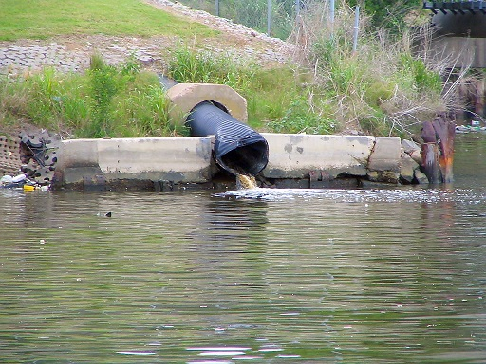
Figure 4a. From http://educatoral.com/rm604/images/per6/g3/
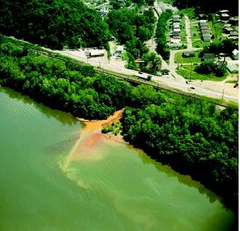
Figure 4b. From http://www.waterencyclopedia.com/Po-Re/Pollution-Sources-Point-and-Nonpoint.html
b. Smoke and exhaust released from factory and power plant smokestacks: causes acid rain which acidifies rivers, lakes and streams. As the pH of our waterways decreases due to acid rain, many species of plants and animals die. Learn more about acid rain by visiting this EPA website.
c. Heat pollution: Factories and power plants use water from streams, rivers and lakes to cool machinery and products. The warm water can be harmful to aquatic organisms if released back into the environment before it has cooled.

Storm Water Runoff (Non Point Source Pollution)
Storm water runoff is the #1 risk to streams, rivers and estuaries in the USA. Every time it rains, pollutants on the surface of soil and paved surfaces are washed into our streams and rivers. Ideally, rain water should soak into the soil rather than run off into waterways carrying pollutants. This is a growing problem. As we develop and pave more land, less rain water can soak into the ground, so the volume of runoff water is rapidly increasing. In recent years the expansion of roadways and construction of neighborhoods, shopping centers and industrial parks has reduced the surface of soil that is able to absorb rain. Paved surfaces and rooftops do not absorb rain water. So, the volume of water that runs off our paved surfaces has increased dramatically. All of this runoff water picks up and carries pollutants into our waterways. Fertilizers, pesticides, leaked oil and other car fluids, industrial waste, manure, soil erosion and litter are all carried to our streams, rivers and estuaries by runoff.
Storm water runoff is a type of Non Point Source Pollution. Non point source pollution is wide spread. It can’t be linked to a specific source. It involves many people and many surfaces. (Ex. fertilizer from many farms; soil sediment from many construction sites etc.) It is difficult to control non point source pollution because many people contribute to the problem. Watch these three video segments ("Why Is Stormwater Runoff a Major New Threat?", "What Are the Costs of Sprawl?", "Is There a Smarter Way to Grow?") on stormwater runoff from the Frontline video Poisoned Waters.
Agricultural Pollutants are common in storm water runoff. Since many farms contribute to the problem, they are generally considered to be non point source pollution. However, in some cases agricultural pollution can be linked to a specific source such as a leaking animal waste lagoon on one specific farm.
There are four types of pollutants that are common in farm runoff. These substances can contaminate nearby waterways.
a. Fertilizers: are applied to increase plant growth; They contain nitrates and phosphates. Watch the "Why Are America's Waterways in Peril?" segment from the Frontline video Poisoned Waters .
b. Pesticides: are used to control weeds, insects and diseases on farm crops
c. Soil Sediments: Rain and improper farming practices can cause erosion of top soil which causes turbidity problems in our lakes, rivers and streams.
d. Manure: animal waste that contains coliform bacteria, nitrates and phosphates. Watch the "What Is the Biggest Polluter of Water?" segment from the Frontline video Poisoned Waters.

Figure 5. An insecticide application to lettuce.
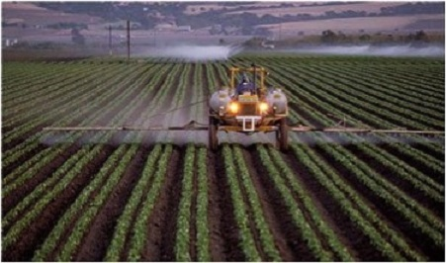
From http://californiaagriculture.ucanr.edu/landingpage.cfm
Figure 6a. Examples of various levels of turbidity in water samples.
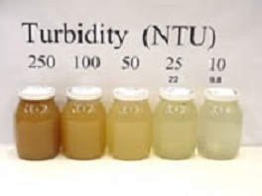
From http://www.water.ncsu.edu/watershedss/info/turbid.html

Figure 6b. Example of turbid water entering Lake Tuscaloosa, Alabama, USA.
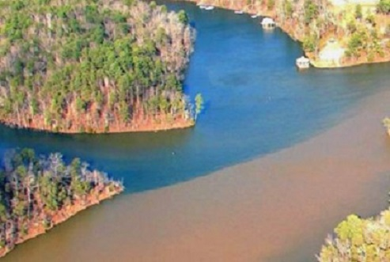
Credit: City of Tuscaloosa, Alabama, from http://water.usgs.gov/edu/turbidity.html
1. CAFOs – Confined Animal Feed Operations: CAFOs are large scale farming operations where thousands of hogs or hundreds of thousands of birds are housed in a small area and produce tremendous amounts of manure. While this is an efficient way to produce meat and eggs, it can be harmful to the environment. The manure can contaminate ground water, streams, rivers and estuaries. CAFOS are a serious problem in Eastern NC. Frequent hurricanes in Eastern NC can contribute to the spread of this pollution. Learn about CAFOs

Figure 7. Location of hog CAFOs in NC. Notice the high concentration in Southeastern, NC.
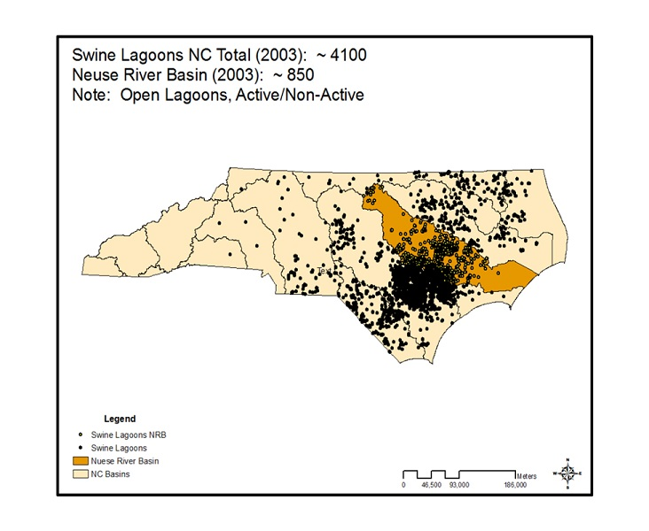
From http://research.cnr.ncsu.edu/blogs/elizabethnichols/files/2011/07/denr-2.jpg

Litter
Litter is a growing problem in our country. Improperly discarded trash ultimately gets carried by rain and wind to the nearest stream which carries it to the nearest river and ultimately to the ocean. This trash has become a big problem for wildlife in rivers and streams and for animal life in the ocean. This is especially true of plastic trash that does not decompose. There is a huge plastic trash heap floating in the middle of the Pacific Ocean. No one knows its exact size because most of it is underwater. It is probably at least as big as the state of Texas. There is a similar but smaller heap in the Atlantic Ocean. Plastic bags and bottles look like jelly fish to sea turtles, ocean fish, birds and mammals. Unfortunately, they are deadly because they block the intestinal tract of these animals. One million sea birds and 100,000 marine mammals and sea turtles die each year from eating plastic trash.
Plastic Paradise (http://plasticparadisemovie.com/). Click on the movie trailer and watch the short video. When the video ends, the next screen you will see should have 3 pictures in a row. Click on the left hand picture that shows 3 people sitting at a long desk (http://vimeo.com/102820414). Watch this interview with Angela Sun (Plastic Paradise producer).
Figure 8. The Great Pacific Garbage Patch.
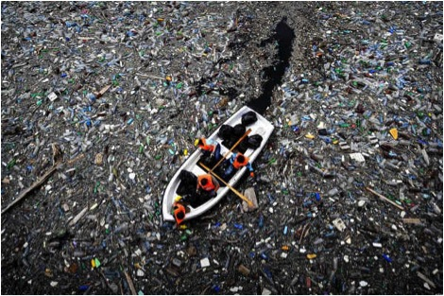
From http://www.flight965.com/2014/05/04/unusual-travel-great-pacific-garbage-patch-pacific-ocean

Vocabulary words:
potable water
nutrients
pesticide
economic impact
point source pollution
storm water runoff
safe water
fertilizer
sewage
water pollution
public health
manure
pollutant
stewardship
non point source pollution
Go to this link to practice these vocabulary words.
www.quizlet.com/67018759/flashcards Search for simselfch1gpowell.
You will take a vocabulary quiz when you are done.

Additional Resources

Bioaccumulation and Biomagnification https://www.youtube.com/watch?v=DxqDaTUh08o

Biomagnification
https://www.youtube.com/watch?v=xI2M97Gl5qM

What Warning Signals Does Nature Give Us?
http://d43fweuh3sg51.cloudfront.net/media/media_files/warningsignals.html

How Can Communities Fight Industrial Pollution?
http://d43fweuh3sg51.cloudfront.net/media/media_files/industrialpollution.html

EPA website
http://www.epa.gov/acidrain/education/site_kids/lucy/1.htm

Why Is Stormwater Runoff a Major New Threat?
http://d43fweuh3sg51.cloudfront.net/media/media_files/stormwater.html

What Are the Costs of Sprawl?
http://d43fweuh3sg51.cloudfront.net/media/media_files/costsofsprawl.html

Is There a Smarter Way to Grow?
http://192.168.33.10/smarter_way.mp4

Why Are America's Waterways in Peril?
http://192.168.33.10/waterways_peril.mp4

What Is the Biggest Polluter of Water?
http://d43fweuh3sg51.cloudfront.net/media/media_files/biggestpolluterwater.html

Concentrated Animal Feeding Operation
http://www.youtube.com/watch?v=Vv7YlxDQhJg

Plastic Paradise
http://plasticparadisemovie.com/

Quizlet Vocabulary Practice
http://www.quizlet.com/67018759/flashcards

Dictionary

Acid Rain
Rain with a pH < or = to 5.5; most normal rain has a pH between 6.0 and 7.0; acid rain harms forests, lake and river ecosystem

Agricultural
Relating to farming

Aquatic
Referring to water; aquatic plants and animals live in water

Cholera
A bacterial disease that causes diarrhea and vomiting and is caught from drinking water that is contaminated with human waste

Community
Interacting populations of plants and animals in a location

Ecosystem
A biological community of interacting organisms and their physical environment

Groundwater
Water held underground in the pores and cracks of soil

Industrial
Relating to factories or industry

Surface Water
Water that collects on the surface of the ground

Toxic
Poisonous

Urban
Relating to a city or town

Water Pollution
Addition of a substance that has a negative effect on the water or the living things that live there

References

1. https://www.youtube.com/watch?v=DxqDaTUh08o
2. https://www.youtube.com/watch?v=xI2M97Gl5qM
3. http://d43fweuh3sg51.cloudfront.net/media/media_files/warningsignals.html
4.http://d43fweuh3sg51.cloudfront.net/media/media_files/industrialpollution.html
5. http://www.epa.gov/acidrain/education/site_kids/lucy/1.htm
6. http://d43fweuh3sg51.cloudfront.net/media/media_files/stormwater.html
7. http://d43fweuh3sg51.cloudfront.net/media/media_files/costsofsprawl.html
8. http://192.168.33.10/smarter_way.mp4
9. http://192.168.33.10/waterways_peril.mp4
10.http://d43fweuh3sg51.cloudfront.net/media/media_files/biggestpolluterwater.html
11. http://www.youtube.com/watch?v=Vv7YlxDQhJg
12. http://plasticparadisemovie.com/
13. http://www.quizlet.com/67018759/flashcards

Chapter 2. Solutions to Pollution

Introduction
Humans are responsible for protecting our water supply. The good health of humans and the environment depend on this. In this section, you will learn about:
1. The two basic rules for dealing with pollution
2. Solutions to Agricultural Pollution
3. How laws, regulations and water quality standards are used to prevent pollution
4. How Technology is used to monitor, measure and clean up pollution
5. The role of Stewardship and how it is used to protect the environment
There are two basic rules for dealing with pollution:
A. The solution to pollution is dilution: When a chemical spill occurs, in the environment, adding water to lower the concentration of the pollutant can reduce the severity of the exposure to organisms. When river water flows into a spill site, the river dilutes the concentration of the pollutant and helps to reduce the exposure of plants and animals at the spill site.
B. The dose makes the poison: The amount of chemical involved in a chemical exposure determines the effect it will have on organisms and the environment. Small amounts of the pollutant may have very little effect on organisms and the environment. But, high concentrations of the same pollutant, could be quite harmful.
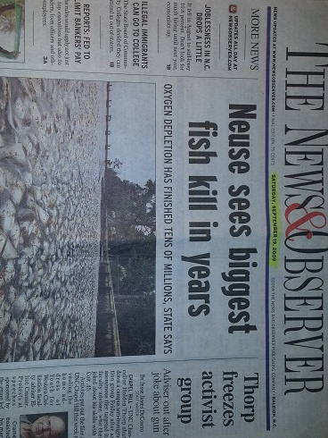
Figure 1. Photo from News & Observer

Solutions to Agricultural Pollution
Farmers have a number of methods to reduce runoff of pollutants from their farms. Federal and state government regulations require farmers to reduce surface water runoff from their farms. Farmers must obey these rules or risk paying fines. One of the simplest and most effective tools used on farms is called a riparian buffer or vegetative buffer strip. Buffers are strips of land on both sides of a river or stream that are planted with trees, shrubs and grasses. Plants growing along the river banks slow the flow of water toward the river and increase the amount of water that soaks into the ground. When more water soaks into the ground, less pollution will enter the river or stream.
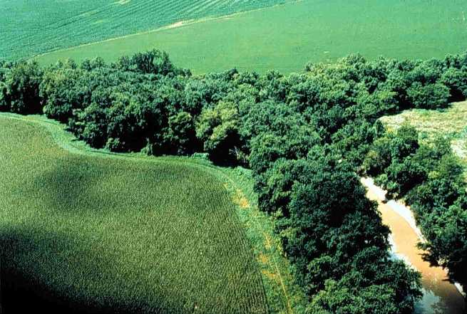
Figure 1. Shows wooded vegetated buffer strips of land on both sides of a river. Photo courtesy of Dr. David Moreau, NCSU, Water Quality Group.
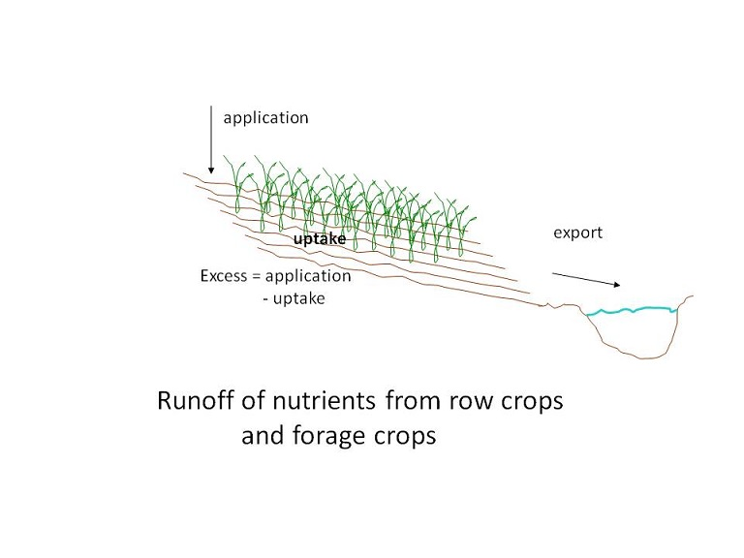
Figure 2. Demonstrates how fertilizer can run off cropland and enter rivers and streams. Photo courtesy of Dr. David Moreau, NCSU, Water Quality Group.
Another common farm practice is contour plowing. Plowing fields across a slope will decrease runoff and increase the amount of water that soaks into the ground.
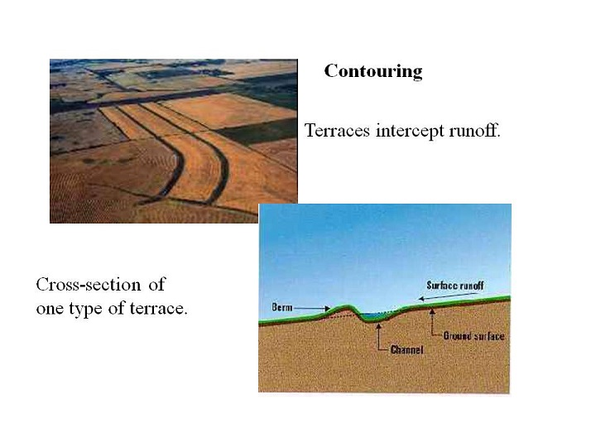
Figure 3. Use of contour plowing to reduce runoff of farm pollution. Photo courtesy of Dr. David Moreau, NCSU, Water Quality Group.
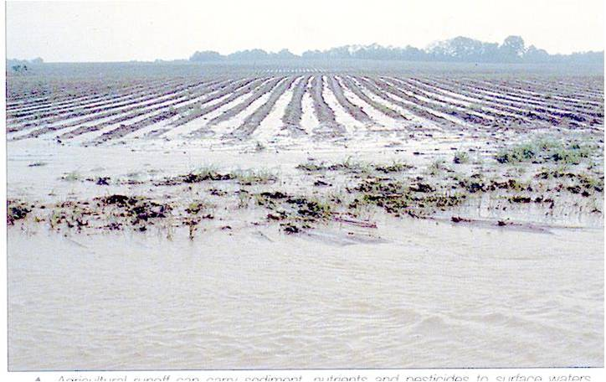
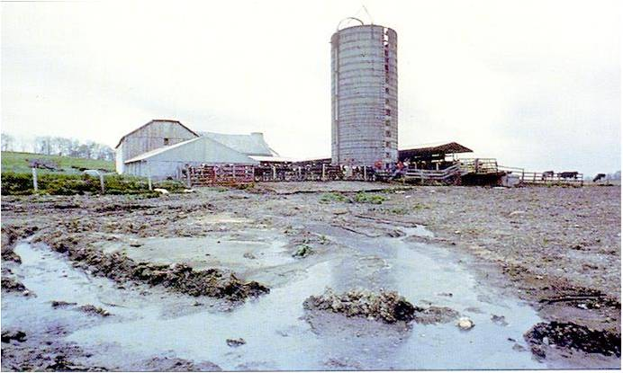
Figure 4. Example of farm runoff from a crop field and from an animal feedlot. Runoff water will eventually contaminate streams and rivers. Photos courtesy of Dr. David Moreau, NCSU, Water Quality Group.
Reduced tillage is another common practice. Farmers leave plant debris from last years’ crop on the soil surface to slow runoff and reduce soil erosion.
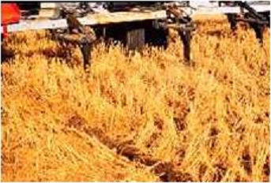
Figure 5. Using crop residue cover to prevent soil erosion and water runoff into streams and rivers. The farmer plants seeds directly into the soil that is covered by crop plants from last year. Photo courtesy of Dr. David Moreau, NCSU, Water Quality Group.
Finally, farmers employ Integrated Pest Management (IPM): This technique reduces use of pesticides and fertilizers which improves water quality. Concentrated Animal Feed Operations (CAFO’s) (large scale farms where thousands of hogs or hundreds of thousands of chickens are raised in crowded barns) dispose of and store animal waste in man made ponds called waste lagoons. Liquid from the ponds is sprayed onto farm fields surrounding the barns and waste lagoons. Despite years of research developing and improving technology to address these large volumes of waste, CAFO’s still pollute our air, rivers and groundwater with animal waste. Many of the CAFOs in our state are located in Eastern North Carolina where ground water is very close to the soil surface so it is easily polluted by CAFOs.
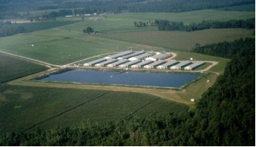
Figure 6. Photograph of a large hog farm (CAFO) with a waste lagoon (large dark rectangular area in front of the barns) and surrounding croplands where animal waste water is sprayed. Photo from NCDENR: http://www.enr.state.nc.us/files/hogs/hogplan.htm

Laws/Regulations/Water Quality Standards
The U.S. Environmental Protection Agency (EPA) is responsible for protecting human health and the environment. EPA does this by writing and enforcing regulations based on laws passed by Congress. Regulations are the rules that will be followed to enforce the laws. The regulations establish water and air quality standards for pollutants. These standards set maximum allowable limits for pollutants from smoke stacks and waste discharge pipes. Government scientists set water quality standards for each body of water. These standards determine the water quality pollution control program that is required for that body of water. Water quality standards, establish how to protect and preserve each body of water.
Today, EPA is responsible for: ensuring the safety of our water, air and drinking water, protecting endangered species and pesticide regulation. EPA controls peoples’ behavior by having consequences for polluters and by rewarding people who protect the environment. The “Stick and Carrot Approach”: punishes people who violate the law (“the stick”) and rewards people who take action to protect the environment (“the carrot”). For example, you can fine polluters: “You will be fined $$$ every day that you continue to exceed the allowable limits for your discharge of pollutants into a waterway.” OR, you can offer a tax credit for helping the environment: “If you invest in equipment that will reduce the amount of pollution that you dump into the river, you will get a tax credit.” Both approaches effectively change peoples’ behavior and promote actions that are good for the environment.

Major Federal Environmental Regulations
Clean Water Act (1972): EPA regulates discharges of pollutants into the waters of the United States and prevents the filling of wetlands. The goal was to make all surface waters drinkable and fishable. However, laws are only effective if they are enforced by government agencies. Click on the following link to see how well we are doing at enforcing the Clean Water Act. "Clean water rules ignored" article by Charles Duhigg from the News and Observer, published September 13, 2009.
Clean Air Act (1972): EPA limits smoke stack emissions of 188 air pollutants from power plants and factories some of which cause acid rain; EPA sets air quality standards for each pollutant. These are the maximum amounts allowed for each pollutant. Six important air pollutants that are regulated are: particle pollution, carbon monoxide, nitrogen oxides, sulfur oxides, mercury, lead and ground level ozone. Just recently EPA announced a plan to reduce carbon dioxide emissions to slow global warming.
Safe Drinking Water Act (1974): EPA sets safe/allowable limits for certain chemical pollutants in drinking water; Establishes maximum allowable limits for 90 contaminants in drinking water. Drinking water treatment plants must ensure that water leaving their facility does not contain contaminants that exceed EPA’s limits. Ex: Arsenic = 0.01ppm; Copper = 1.3ppm. Click on this link to see the list of 90 contaminants that are regulated by the SDWA. Click on this link to see an example of how the town of Cary complies with this law.
Endangered Species Act (1973): Protects animal and plant species that are at risk of extinction; also protects the habitats of these species; many endangered species live in wetlands so this law impacts many aquatic ecosystems.
State Regulations: In addition to federal laws and regulations, every state has additional state laws and regulations. State regulatory agencies such as North Carolina Department of the Environment and Natural Resources (NCDENR) monitor and enforce the state laws and regulations. NCDENR writes and enforces rules to protect waterways from pollution; Riparian buffers are required along many rivers to prevent runoff from farms, roads, construction etc. Both the Neuse River and Jordan Lake are important sources of drinking water in NC. Both Raleigh and Garner get their drinking water from Falls Lake which is in the Neuse River basin. Cary and Morrisville get their drinking water from Jordan Lake. The Neuse River Basinwide Water Quality Management Plans were put in place in 1993, 1998, 2002 and 2009 to address water quality problems in the Neuse River Basin.
Click on these links to learn more about the Neuse River:
Nutrients: "Neuse River Wary of 95 Fish Kill" - News & Observer, November 14, 2005.
Nutrients: "Neuse sees biggest fish kill in years" - News & Observer, September 19, 2009.
Nutrients: "Give Me Back My River by the Neuse River Keepers" (https://www.youtube.com/watch?v=eHeUN6rr_us). In 2007 the Neuse River was identified as the 8th most at risk river in the US.
The Jordan Lake Rules were written in 2009 to address nutrient overload in Jordan Lake. Local towns and cities were in the process of implementing these rules by reducing the amount of nutrients they dump into the Haw River/Jordan Lake via storm water and treated sewage. In 2013, the NC Legislature passed a law that required that a new approach “the solar bee” be tried to clean up Jordan Lake. The Jordan Lake rules will not be enforced until the results of this new experiment are available. Click on this link to learn more about the Jordan Lake Rules and this link for the Jordan Lake solar bee experiment.

How safe and drinkable is the water around North Carolina?
Technological advances have enabled us to collect data about water quality. The more we understand and respect NC’s aquatic systems, the more able we are of making informed decisions and becoming good stewards of the environment. Point and non-point pollutants such as surface runoff, and industrial inputs can impact plant and animal populations. Clear water may contain odorless, tasteless and colorless harmful contaminants. Water must be tested for contaminants such as: bacteria, nitrates, arsenic and others. Natural supplies of drinking water are limited and do not exist in sufficient quantities to meet human needs. Because of this humans have developed water treatment methods that clean water so that it can be used safely.
Many people believe that bottled drinking water is safer than tap water. This is not usually true. The Safe Drinking Water Act requires that tapwater is tested and treated for contaminants before it is sent to your house. No such laws exist for bottled water. View this link to learn more about bottled water, and this link for Bottled Water vs Tap Water on 20/20.
Accidental spills of sewage and coal ash into NC rivers do occur and have an impact on water quality. Runoff from contaminated land at factory sites and leaking under ground chemical storage tanks can sometimes pollute rivers and groundwater. Read these links to learn more about some water pollution problems in NC water:
Coal ash spill could push NC to move more aggressively on environmental threats –News &Observer-Feb 22,2014
Sewage: Sewage Spills into Haw River –News &Observer-Feb 1,2014
PCBs: Fisherman alerted to PCBs–News&Observer-May21,2004
PCBs: Crabtree Creek fish toxic –News&Observer-July 16,2005
TCE in well water: Cleaning up toxic mess will cost taxpayers Watch this video.

Fracking
“Fracking” is a term that is short for Hydraulic Fracturing. This method is used to extract oil or natural gas from shale deposits inside the Earth’s crust. Chemicals and water are injected into a deep natural gas well under pressure to fracture the shale rock and release the natural gas. Fracking is known to have contaminated ground water in other states.
Fracking for natural gas will be permitted in NC starting in 2015. Our state is currently developing rules to regulate the fracking industry in NC. The effectiveness of these rules will determine how well they will protect our groundwater from fracking.
The North Carolina Department of the Environment and Natural Resources is responsible for protecting the environment in NC. Their water quality division focuses on protecting our groundwater and waterways. Since 2011, the number of employees working in this Water Quality Division has been cut from 660 to 435, just as our state prepares to allow fracking for natural gas and deal with the issue of toxic coal ash waste.
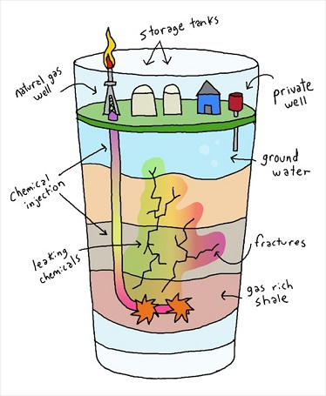
Figure 1. Fracking Diagram from http://www.thegreenpavilion.com.au/pages/Fracking-%28hydraulic-fracturing%29-explained-simply.html
Read these articles to learn more:
NC panel passes chemical disclosure. (http://www.newsobserver.com/2014/01/14/3532704/nc-fracking-panel-passes-chemical.html)
Officials OK rule to force fracking on NC landowners (http://www.newsobserver.com/2013/08/28/3145187/officials-ok-rule-to-force-fracking.html)
Cuts to DENR Regulators Jarring in wake of Dan River spill (http://www.newsobserver.com/2014/03/07/3683762/cuts-to-denr-regulators-jarring.html)

Technology
Technology is the use of tools or techniques to solve a problem. There are three major ways to use technology to solve water quality problems. Technology can be used to: 1. Monitor and measure pollution over time. 2. Clean up pollution and 3. Prevent pollution.
a. Monitoring and measuring pollution: Scientists can determine the water quality of a stream, river or lake by measuring: nitrate, phosphate, dissolved oxygen, pH, coliform bacteria and turbidity in waterways. They can measure treated drinking water to confirm that it meets all Water Quality Standards set by EPA. Scientists can measure the water discharged from a factory to ensure it does not violate the discharge permit for that factory. For this unit, we will focus on learning about how scientists measure water quality of streams, rivers and lakes.
b. Cleaning up pollution: Technology at a drinking water treatment plant is designed to remove contaminants. When the drinking water first enters the treatment plant, it is definitely undrinkable. The treatment plant removes contaminants and makes it safe to drink.
Drinking water treatment requires some basic steps:
1. Water collection/first filtration to remove large objects.
2. Coagulation: lime and alum are added to the water causing particulates to clump together.
3. Flocculation: the water is shaken to form larger clumps called flocs.
4. Sedimentation: the water stands for 24 hours allowing clumps to settle to the bottom.
5. Filtration: through sand and gravel to remove fine particles
6. Disinfection: chlorine is added to kill germs
7. Aeration: air is pumped through the water to evaporate chlorine.
These steps remove: suspended solids, bacteria, algae, viruses, fungi, minerals and chemical pollutants. Newer technologies such as carbon adsorption treatment or reverse osmosis membranes can be used to remove chemicals from drinking water to meet the Water Quality Standards that are required by the Safe Drinking Water Act. Click on this link (This powerpoint was provided courtesy of Dr. Joel DuCoste, NCSU, Dept of Civil Engineering) to watch a slideshow on drinking water treatment.
c. Preventing pollution Technology can be used in a factory or sewage treatment plant to capture pollutants before they are released into the environment For example, smoke stack scrubbers, catalytic converters in cars, sludge recapture devices in sewage treatment facilities all remove pollutants so they never enter the environment. Sewage treatment is an excellent example of how technology can be used to prevent pollution from entering the environment.
Wastewater treatment plants: Sewage from your home (human waste) travels through pipes to a wastewater treatment plant where it goes through a series of steps designed to remove pollutants.
1. Preliminary filtration: coarse grates remove large objects,
2. Primary treatment: removes solids (sludge settles and can be collected and made into fertilizer),
3. Secondary treatment: gravel filtration to remove smaller particles,
4. Aeration: water is pumped into and stored in open pools where aeration, sunlight and evaporation help clean it,
5. Disinfection, chlorine may be added to kill bacteria before the water is returned to a river, or used for irrigation or industrial water needs.
In rural areas, where sewage systems are not available, people use septic tanks to collect, treat and dispose of human waste.

Figure 1. Diagram of a septic tank and drainfield.
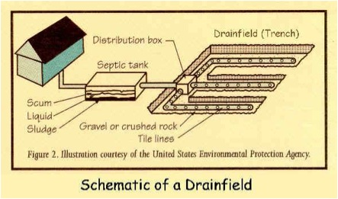
From http://www.giwastemanagement.com/Septic-Tank-Education.html

Stewardship
Individual and group action is needed to protect our water from pollution. This is called stewardship. The first step in getting students to move towards stewardship is to create a personal awareness of how they are connected to NC’s water system. Water quality determines the health of ecosystems. It impacts human activities such as agriculture, fishing and recreation as well as human health. Good water quality supports healthy environments in which diverse communities of organisms can exist. The importance of monitoring and maintaining water quality cannot be overstated. Cultivating self awareness of a connection to North Carolina’s water system is essential to ensure that future generations of citizens and leaders value the importance of clean water. They must understand the need for managing our water resources (resource management) to ensure that future generations will have a clean safe water supply. Both water conservation (using less) and environmental protection of our water are important parts of resource management.
Click here for link to the "Pollution...What's Our Connection?" pamphlet from NCDENR.
Click here for link on N.C. Environmental Education. Click on "North Carolina's Environmental Education". Select "Resources". Select "River Basin Program".
Scroll down to "Discover NC's River Basin Booklet". Click on "Discover NC's River Basins". Scroll through the booklet skimming the text.

Vocabulary words:
technology
regulations
resource management
filtration
coagulation
Clean Water Act
Safe Drinking Water Act
stewardship
septic tank
riparian buffer
floculation
disinfection
conservation
drinking water treatment plant
water quality standards
waste water treatment plant
aeration
Clean Air Act
Endangered Species Act

Go to this link to practice these vocabulary words.
www.quizlet.com/67026837/flashcards Search for simselfch2gpowell.
You will take a vocabulary quiz when you are done.

Additional Resources

Clean water rules ignored: Records show violations are up, but sanctions aren't
Almost four decades ago, Congress passed the Clean Water Act to force polluters to disclose the toxins they dump into waterways and to give regulators the power to punish offenders. States have passed pollution statutes of their own. But in recent years, Clean Water Act violations have risen steadily across the nation, an extensive review of water pollution records by The New York Times found.
In the last five years alone, chemical factories, manufacturing plants and other workplaces have violated water pollution laws more than half a million times. The violations range from failing to report emissions to dumping toxins at concentrations regulators say might contribute to cancer, birth defects and other illnesses.
However, the vast majority of those polluters have escaped punishment. State officials have repeatedly ignored obvious illegal dumping, and the Environmental Protection Agency, which can prosecute polluters when states fail to act, has often declined to intervene.
Because it is difficult to determine what causes diseases like cancer, it is impossible to know how many illnesses are the result of water pollution.
But concerns over these toxins are great enough that Congress and the EPA regulate more than 100 pollutants through the Clean Water Act and strictly limit 91 chemicals or contaminants in tap water through the Safe Drinking Water Act.
Regulators themselves acknowledge lapses. The new EPA administrator, Lisa P. Jackson, said in an interview that despite many successes since the Clean Water Act was passed in 1972, today the nation's water does not meet public health goals, and enforcement of water pollution laws is unacceptably low. She added that strengthening water protections is among her top priorities. State regulators say they are doing their best with insufficient resources.
The Times obtained hundreds of thousands of water pollution records through Freedom of Information Act requests to every state and the EPA, and compiled a national database of water pollution violations. In addition, The Times interviewed more than 250 state and federal regulators, water-system managers, environmental advocates and scientists.
That research shows that an estimated one in 10 Americans has been exposed to drinking water that contains dangerous chemicals or fails to meet federal health benchmarks in other ways.
Those exposures include carcinogens in the tap water of major American cities and unsafe chemicals in drinking-water wells. In general, wells, which are not typically regulated by the Safe Drinking Water Act, are more likely to contain contaminants than municipal water systems.
Some violations are relatively minor. But about 60 percent of the polluters were deemed in "significant noncompliance" -- meaning their violations were the most serious kind, like dumping cancer-causing chemicals or failing to measure or report when they pollute.
The Times' research shows that fewer than 3 percent of Clean Water Act violations resulted in fines or other significant punishments by state officials. And the EPA has often declined to prosecute polluters or force states to strengthen their enforcement.
Numerous state and federal lawmakers said they were unaware that pollution was so widespread.
"I don't think anyone realized how bad things have become," said Rep. James L. Oberstar, D-Minn., when told of The Times' findings. Oberstar is chairman of the House Transportation and Infrastructure Committee, which has jurisdiction over many water-quality issues.
"The EPA and states have completely dropped the ball," he said. "Without oversight and enforcement, companies will use our lakes and rivers as dumping grounds -- and that's exactly what is apparently going on."

Safe Drinking Water Act
http://water.epa.gov/drink/contaminants/index.cfm

Town of Cary website
http://www.townofcary.org/Departments/townmanagersoffice/pio/News_Releases/news2013/psa_wqr.htm

Neuse ever wary of ’95 fish kills
News & Observer 11/14/2005
River is cleaner; fish may be fewer
BY WADE RAWLINS, STAFF WRITER
NEW BERN - A decade after the death of millions of fish triggered a wide-ranging cleanup of the Neuse River, fish kills still happen in the river’s coastal waters. But their numbers haven’t approached the carnage of the fall of 1995.
Images of the masses of floating fish, and fears that the river might be unhealthful for people as well, prompted new state laws and regulations designed to keep nitrogen, the main pollutant afflicting the Neuse, out of the water.
Ten years later, scientists say the Neuse is cleaner. Sampling shows the amount of nitrogen in the water has dropped, but scientists aren’t sure why. “The evidence we have is things are getting better,” said David Moreau, chairman for the state panel that passed the Neuse River cleanup plan in 1997. “It may have been we are just lucky.”
Nitrogen acts as fertilizer, stimulation growth of aquatic plants and algal blooms. When the plants die, their decomposition can rob the water of oxygen for a time and cause fish kills. In response to the massive kills in the 1990’s, state environmental regulators adopted rules aimed at reducing by 30 percent the nitrogen reaching the Neuse River by 2003. The rules affect logging, development, sewage plants, factories, and farms.
Craig Stow, a professor of environmental health sciences at the University of South Carolina, said his research showed a 27 percent decrease in nitrogen concentration in the Neuse in 2003 compared with 1991-95. But Stow said it would be a stretch to say that is the reason for fewer fish kills. Differences in weather of the intense hurricanes that inundated North Carolina in the late 1990s may have played a role, said Hans Paerl, professor of marine and environmental science at the UNC- Chapel Hill Institute of Marine Sciences.
Paerl said some of the hurricane floodwaters that initially caused large fish kills may have had a longer-term cleansing effect. One hypothesis is that the hurricanes scoured the river basin, pushing nitrogen out of the river into Pamlico Sound.
The Neuse rises northeast of Durham and flows southeasternly for more than 200 past Raleigh, Smithfield, Goldsboro and Kinston to Pamlico Sound. Below New Bern, about 120 miles east of Raleigh, the river widens to several miles across, and the current of the tea-colored water slows.
Fish kills in the Neuse occur primarily in this stretch of slow-moving water. In recent years, the vast majority of the fish kills statewide occurred here. In 2003, 3.2 million fish, largely menhaden, died in the lower Neuse, mostly in two large events. The state blamed the kills on wind-driven upwelling of water containing low dissolved oxygen. The state said water samples showed that a diverse mix of algae species also may have contributed to the problem. Other than 2003 and 2004, the number of fish killed in the Neuse has dropped to less than 500,000 a year, state records show.
The state’s Neuse River Rapid Response Team, created to put marine biologists on the scene of fish kills, has gone out to only a half-dozen events so far this year. Retired Neuse River Keeper Rick Dove, who lives on the river, speculated that fish kills are fewer simply because there are fewer fish in the river, particularly menhaden, one of the primary victims.
Commercial catch statistics show the annual catch of Atlantic menhaden ranged from 48 million to 69 million pounds since 2000. In the 1970s and early 1980s, annual catches often topped 100 million pounds.
“This year I didn’t see enough menhaden at my dock to throw a cast net,” Dove said. “Usually in August, the water is covered black with them.”

Neuse sees biggest fish kill in years
http://www.newsobserver.com/2009/09/19/92575/neuse-sees-biggest-fish-kill-in.html

Give Me Back My River by the Neuse River Keepers
https://www.youtube.com/watch?v=eHeUN6rr_us

Jordan Lake Rules
Read the first two paragraphs about the Jordan Lake Rules.
http://portal.ncdenr.org/web/jordanlake/background

Jordan Lake Solar Bee Experiment
News&Observer - Dec 14,2013
http://www.newsobserver.com/2013/12/14/3457928/with-jordan-lake-experiment-nc.html

Bottle Water
http://news.nationalgeographic.com/news/2010/03/100310/why-tap-water-is-better/?rptregcta=reg_free_np&rptregcampaign=20131016_rw_membership_n1p_us_ot_c1#finished

Bottle Water vs Tap Water
Bottle Water vs. Tap Water on 20/20
https://www.youtube.com/watch?v=9e5CaIkrqWU

Crabtree Creek fish toxic: High PCB levels found in 2 species
State health officials on Friday warned the public to limit consumption of catfish and carp from Crabtree Creek.
The state also plans more testing in Umstead State Park to see whether the fish have high levels of toxic chemicals.
The latest warning while less restrictive than fish advisories for Lake Crabtree and the creeks upstream extends the health postings linked to the ongoing Ward Transformer Superfund investigation into the southern edge of Umstead State Park. The advisories warn of high levels of toxic chemicals called polychlorinated biphenyls or PCBs, which were once widely used by manufacturers.
PCBs build up in the tissue of fish and when consumed by humans increase risk of cancer and other health and learning problems.
Luanne Williams, a toxicologist with the state Department of Health and Human Services, said the state has only limited PCB testing data from Crabtree Creek and needs more. The creek drains Lake Crabtree and meanders three to four miles across the southern part of Umstead State Park, but is not heavily fished, park officials said. It does not flow into the park's most popular fishing lakes.
"We are going to do some additional sampling within Umstead State Park to see if we need to issue an advisory for the creek that runs through the park," Williams said. "We just want to make sure that people are protected. That is the bottom line."
Last year, the state posted signs at Lake Crabtree County Park warning people not to eat any catfish or carp from the recreational lake. Fish from the lake contained levels of PCBs that were more than twice the level at which the U.S. Environmental Protection Agency recommends no consumption because of the higher long-term risks of cancer, and learning deficiencies in children.
Raleigh, Cary and Wake County leaders have named a task force to gather more information about the contamination and press for a clean-up of the Ward Transformer site, which has been contaminated more than 25 years.
"The state health advisory is most discouraging news," Raleigh Mayor Charles Meeker said. "It indicates the PCBs are spreading downstream. This shows that the cleanup should occur right away before the toxins spread further."
Williams said the limited fish sampling data the state had from Crabtree Creek, just downstream of Lake Crabtree, showed lower levels of PCBs in catfish, but still enough to be of concern. The new advisory warns people to limit consumption of catfish and carp from Crabtree Creek to no more than one meal per month.
Williams said the state would sample PCB levels in largemouth bass as well as catfish in the creek.
"The sampling should start in the next few weeks," Williams said. "I've asked the Division of Water Quality to do the sampling for us so we can get a better idea of how far this advisory should go and if we should add largemouth bass to this advisory."
Park Ranger Bob Davies posted fish advisory signs in English and Spanish at the bridge where the park's company mill trail crossed Crabtree Creek.
The park attracts about 480,000 visitors a year, and park officials estimate that about 7 percent of the visitors do some fishing, primarily in Big Lake, Sycamore Lake and Reedy Creek Lake.
Davies said he rarely saw people fishing the creek inside the park because of its distance from parking areas.
"It's a pretty good long hike to go fishing," Davies said. "The time a year, there is hardly any flow in the creek unless we get a down pour. You really can't paddle a canoe down it."
Federal and state investigators have tracked waterborne pollution downstream from a tributary below Ward Transformer through Little Brier Creek, Brier Creek Reservoir and Brier Creek into Lake Crabtree.
Based near Raleigh-Durham International Airport, Ward Transformer reconditions transformers, which convert high voltage electricity carried by power lines to lower-voltage current. Ward and many other manufacturers used PCBs as insulators or coolants in transformers until 1979, when Congress banned their manufacture. The way Ward handled PCBs in the 1960s and 1970s led to widespread site contamination. The toxins have moved slowly downstream as particles of contaminated soil.
The U.S. Environmental Protection Agency is negotiating with Ward Transformer to clean up the contamination this year to prevent any further spread of PCB contamination from the. But a lawyer for Ward Transformer said the company cannot afford to undertake a multi-million dollar clean-up.

Coal ash spill could push NC to move more aggressively on environmental threats
News &Observer-Feb 22,2014
http://www.newsobserver.com/2014/02/22/3643798_ash-spill-could-push-nc-to-move.html?rh=1

Sewage spills into Haw river
RALEIGH — A crack in a main sewer line for the city of Burlington caused 3.5 million gallons of untreated wastewater to spill this week into the Haw River, which feeds into the drinking water supply for roughly 300,000 people in the Triangle.
Ranking among the largest spills in recent history, the leak from Monday through Wednesday put the equivalent of six Olympic swimming pools of sewage into the river.
Burlington, following state law, didn’t make a public notification until the leak ended, potentially exposing recreational users of the river to pathogens, according to an academic expert.
However, the town of Pittsboro – the closest downstream user of the Haw – has seen no signs of contamination or biological impact from the three-day overflow. The week’s cold weather likely limited bacterial growth and kept recreational users away from the sewage, said Corey Basinger, a regional supervisor for the state Division of Water Resources.
The overflow resulted from a failure of one of the most important pipes in Burlington’s sewer system, compounded by icy weather, according to the state Department of Environment and Natural Resources.
Burlington officials on Monday night noticed a crack several feet long in the “force main” that pushes sewage uphill to the East Burlington Wastewater Treatment Plant. The plant, one of two for the city, can handle up to 12 million gallons of sewage per day.
The city notified a state-run emergency response unit within an hour. That night, Burlington shut down the failing line, which is 55 years old. Within hours, the city installed a pumping system and pipe to reroute the effluent.
But the city’s emergency replacement pumps weren’t powerful enough to force all the sewage uphill through 600 feet of temporary replacement line, Basinger said.
“The equipment that they had on hand was not quite sufficient to stop the overflow – not quite large enough,” he said.
Wastewater soon backed up and overflowed from large, trap-door style manholes in a wooded area near the plant, eventually seeping down to the Haw River.

Public notice took days
While downstream municipalities and state agencies were notified immediately, Burlington did not send out a media advisory or other public notification until Thursday, Basinger said. State law allows governments to make that announcement up to 48 hours after sewage reaches rivers, creeks and lakes.
Kenneth Reckhow, an academic expert in water quality, said authorities waited too long to notify the public.
“If by chance they were in the Haw boating and they put their hands in the water, where this came through, then that might be a concern,” said Reckhow, a Duke University professor emeritus of water resources. “I think as soon as they notice that (a leak has) occurred, it seems that it should be required to provide that notice. For boaters, kayakers, it would be something they would want to be aware of.”
It is not clear when sewage first touched the Haw River. Basinger said state and city officials wanted to have a full accounting of the accident before making public statements. City officials weren’t immediately available for comment, but Burlington was acting on the advice of the Division of Water Resources, according to the Times-News of Burlington.
“We wanted to ensure the city had proper public information,” Basinger said. Speaking too early could have caused confusion and required further statements, he added. Asked about a potential hazard to uninformed boaters near the plant, he pointed out that extremely cold temperatures had largely cleared the Haw of recreation.
“We felt we had made notifications to all the pertinent parties – state agencies and sister agencies,” Basinger said. “Those are requirements that are set in statute.”
Though the leak was the largest that many involved could remember, it ultimately was a trickle compared to the flow of the Haw, which was close to 200 million gallons per day this week.

Little long-term impact
Burlington crews stopped the leak Wednesday afternoon by installing a huge temporary pump. The city is still working to repair the force main.
Thirty miles downstream, the town of Pittsboro hasn’t spotted any dead fish or seen any changes in the measurements of its drinking water, which it draws from the Haw near U.S. 15-501.
“If they hadn’t told me, I wouldn’t have known there was a spill,” said Adam Pickett, superintendent of water treatment for Pittsboro. “It was a large spill, and I hate it, but hopefully … it’ll blend really well and there won’t be any adverse effect.”
Reckhow, the Duke expert, agreed that the spill would not be measurably harmful in the long term to water quality in the Haw or in Jordan Lake. The cold weather should repress organic growths, and any bacteria or viruses would die quickly, he said. At most, he said, the wastewater could feed algae in the Haw.
Both the state and the city of Burlington will investigate why the failure happened and how it could have been prevented, Basinger said.
“We will review with them any precautionary measures that need to be taken moving forward on any similar-sized lines and aged lines, to make sure we don’t have other issues that come to light,” he said.
State rules require yearly inspections of lines like the one that failed; records of the most recent inspection weren’t immediately available.
Basinger praised Burlington’s response to the leak. Equipment failure is unpredictable, and the city’s emergency equipment was inadequate only because of the magnitude of the situation, he said.
“We were very impressed by their response,” he said. “To get this pump-around in place – during some very adverse weather conditions, in the middle of the night – it was the perfect storm, it really was.”
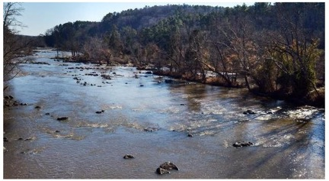

Fishermen alerted to PCBs
Lake Crabtree, a popular Wake County recreation spot, has become the first in North Carolina to post warnings about eating fish tainted by PCBs. The Environmental Protection Agency found high levels of polychlorinated biphenyls, an oily, toxic chemical, in catfish and carp in the lake—and in Brier Creek, which feeds it—during an investigation of Ward Transformer Sales & Service Inc. The company is linked to one of the state’s most infamous pollution cases.
EPA officials are studying the extent of pollution to develop a cleanup plan for the 11-acre Ward site, which was put on the national priority list for investigation in April 2003.
Investigators have found elevated levels of toxic chemicals, most notably PCBs, on the Ward site in an industrial area near Raleigh-Durham International Airport and in adjacent streams. Before 1972, stormwater runoff from the site was uncontrolled. PCBs were added to oil in transformers and other electrical equipment to retard fires until their manufacture was stopped in the United States in 1977 and banned in 1979. They build up in the bodies of animals, move up the food chain and can cause health problems such as skin irrigation, liver damage and cancer.
Luis Flores, project manager for the Ward investigation in the EPA’s Atlanta office, said the agency can’t say definitively that the PCBs in Lake Crabtree came only from Ward Transformer, but it is a likely source.
“We haven’t really finished the investigation,” Flores said. “I guess at this point we don’t know of any other source of PCBs in the area.”
Dr. Luanne Williams, a toxicologist with the state Department of Health and Human Services, said the contamination levels in Lake Crabtree fish were similar to those found in fish upstream in Brier Creek Reservoir. She has asked the EPA to follow the trail of waterborne pollution farther and test fish from Crabtree Creek. The creek drains Lake Crabtree and flows east through Umstead State Park.
“Right now, we don’t know what the levels are in that park,” Williams said.

Stocking stopped
Park rangers have posted 26 signs in English and Spanish around Lake Crabtree warning the public not to eat catfish or carp, and to limit meals of other fish from the lake to no more than one a month. They also put up 10 signs not to eat any fish from Brier Creek.
They have handed out fliers in English and Spanish as well. A good portion of the visitors are Hispanic.
“The Primary concern is from consuming the fish,” Williams said. “The fish can concentrate the PCBs at much higher levels than what is found in the sediment and water.” The levels of contamination in the sediment and water do not pose a risk to people, Williams said.
The latest confirmation of contamination follows findings in December of fish with high levels of PCBs in the lower reaches of Little Brier Creek (downsteam of Brier Creek Parkway), Brier Creek Reservoir and an unnamed tributary, all downstream from Ward and upstream of Lake Crabtree.
While those creeks are remote and fished infrequently, Lake Crabtree County Park attracts 250,000 to 300,00 visitors a year. About 10 percent of them come to fish, Park Manager Drew Cade estimated.
Besides posting warning signs, Cade said, the county discontinued its practice of stocking the lake with catfish and keeping the fish feeders filled to attract fish. “We have decided it’s not the best use of resources to fatten fish up in a lake when we don’t want people to consume them,” Cade said.
Slim Broadwell of Raleigh, an apartment maintenance worker and avid fisherman, came to the park Thursday to fish on his day off and was “not real happy,” he said, to see the advisories posted near the pier.
“I wouldn’t be able to eat what I caught,” Broadwell said as he watched a fish nibble his bait, causing the bobber to wiggle in the water. “I like eating them.” Cade said the park couldn’t prevent people from eating what they caught but would promote “catch-and-release” fishing instead. “You can handle the fish,” he said. “The water is safe. You have to consume the flesh to get the contamination.

$20 million spent
Flores, the EPA project manager, said the agency has not estimated the cost of the Ward superfund cleanup. Over the years, contamination from Ward Transformer has cost taxpayers close to $20 million. Robert E. Ward III, president of the company, could not be reached for comment.
The Ward Transformer plant caught the state’s attention in 1978 after a contractor hired by the company sprayed 30,000 gallons of oil contaminated with PCBs along more than 200 miles of rural roadsides in 14 counties. That year, new federal rules had restricted the disposal of PCBs, significantly raising the cost legal disposal.
The illegal spraying caused a health panic. State workers dug up the contaminated soil and buried it in a landfill in Warren County over vehement objections of residents there. Robert “Buck” Ward, father of the company’s current president, eventually was convicted of federal charges involving illegal dumping of toxic waste, and served nine months in a federal prison. He died in 1996.
In October 1999, the federal and state governments recouped $3.5 million from the estate of “Buck” Ward to cover the cost of cleaning up the roadsides and building a landfill. The Warren County PCB landfill recently was decontaminated and closed at a cost of $18 million.
Ward’s current process of reconditioning transformers complies with environmental regulations, state officials said. However, the process that the company used from 1964 to 1979 allowed PCBs to escape into the environment.
Federal investigators took water and soil samples from the plant site in 1978-1979 and 1993, but they said the levels of contamination found did not pose a threat to public health that required immediate removal. In 1997, state investigators found contamination in a stream and wetlands below the site and recommended further action, which required listing on the Superfund national priority list.

TCE in well water
http://www.wsav.com/story/20949819/nbc-17-investigates-cleaning-up-toxic-mess-in-wake-forest-will-cost-taxpayers

NC panel passes chemical disclosure rules.
Fracking companies won the right to keep secret the chemical cocktails they pump underground during shale gas drilling in North Carolina under a chemical disclosure rule approved Tuesday by the N.C. Mining and Energy Commission.
The public safety standard will help the energy companies protect their secret sauce used in natural gas drilling, but critics said it would also keep residents in the dark about potent chemicals used near local farms and waterways.
The rule passed unanimously after nearly three hours of intense debate Tuesday, and it follows more than a year of deliberations that had the commissioners tied up in knots. Commissioners sought to appease frightened residents, the energy industry and lawmakers eager to promote drilling for economic development.
The rule as passed by the commission is merely a recommendation to the state legislature, which will have final say over fracking standards later this year or next year. But as it now stands, the rule puts North Carolina among the states that don't require energy exploration companies to turn over corporate trade secrets to government agencies for safeguarding in case of emergency.
A lot of folks have heartburn because there are some states that do take possession of the trade secret, said Commission Chairman James Womack. We will have safe and responsible drilling in North Carolina.

Review of trade secrets
Several experts said Tuesday that in some ways, North Carolina's standard for chemical disclosure is more stringent than the public protections of many states that allow fracking. In this state, for example, a corporate trade secret claim would undergo an agency review to make sure it wasn't bogus.
They get an opportunity to call B.S. on a bad claim,” said Wayne Angelo, a Washington D.C., lawyer who represents industrial clients on energy and environmental issues related to fracking.
Shale gas exploration is under moratorium in North Carolina as the Mining and Energy Commission races to complete more than 100 regulations to protect the environment and public health.
Chemicals are used in fracking to break up shale rock and release trapped gas and prevent pipe corrosion. They do not have to be publicly disclosed under a 2005 congressional exemption to the Safe Drinking Water Act, prompting states to come up with their own standards. The chemicals range from household cleansers to food additives and industrial solvents.
North Carolina's rule, if approved by lawmakers, will require that any trade secret claim be reviewed by the N.C. Department of Environment and Natural Resources. The review process has not been created but would require a sworn statement from the company that the trade secret has not been publicly disclosed elsewhere.
The rule requires that permitees provide relatively detailed justifications when they claim trade secrets, said Hannah Wiseman, a law professor at Florida State University who studies fracking regulations across the country.

Access complicated
Operators at a drill site are required by federal law to keep a safety sheet detailing chemicals used on that site; they are also required to turn over the data to public officials during a spill or accident.
But getting the same data off-site is more complicated. Such a request would be handled by calling a 24-hour phone number, to be staffed by the energy company, as called for by North Carolina's rule. The company would have two hours to disclose the information to medical professionals and emergency responders, but it's not clear how the company would validate that the request is legitimate and authorized.
Many have criticized this process as unworkable, especially if residents complained of polluted water or delayed symptoms long after the company and its contractors had left the state.
An individual can be sick, hospitalized, drunk or have the phone off the hook, John Wagner, a Chatham County resident, told the commission. Access means full and immediate access, not access to material at the office, or in a safety deposit box that is available on the next business day.
Chemicals shielded as trade secrets are commonly known by chemists and scientists, so the only issue is which chemicals a company is using in its mixture, and in what combinations.
The secrecy thing is to me a joke; said Commissioner Vikram Rao, a former chief technology officer for energy conglomerate Halliburton. The secret, such as it is, is only of value to the competitor.

Officials OK rule to force fracking on NC landowners
North Carolina landowners would be forced to sell the natural gas under their homes and farms whether they want to or not under a fracking recommendation approved Wednesday that's expected to be enacted by the state legislature this fall.
The proposal by a state study group endorses a rarely used 1945 law that's never been tried here on the kind of scale that would be required for shale gas exploration, or fracking. Thousands of property owners could potentially be affected in the state's gas-rich midsection in Lee, Moore and Chatham counties.
The recommendation, dealing with one of the most emotional fracking issues, bypasses the N.C. Mining and Energy Commission, which holds regular public hearings on protecting the public and safeguarding the environment, and goes to the legislature.
We are talking about a for-profit industry taking away personal freedoms with the blessing of the government, Therese Vick, a community activist with the Blue Ridge Environmental Defense League, told the Compulsory Pooling Study Group. Personal freedoms are seldom on the radar when the gas companies come to town.
The panel does include four members of the Mining and Energy Commission, some of whom were deeply conflicted.
I find it abhorrent personally that a simple majority of landowners could dictate what I can do with my land, said James Womack, chairman of the Mining and Energy Commission and a member of the Lee County Board of Commissioners.
But Womack voted for the practice, called forced or compulsory pooling, saying there are compelling reasons to justify it. Forced pooling protects local residents from inadvertently having their gas sucked out without compensation and keeps neighbors from profiting from resources under someone else's land.
It also makes fracking possible by preventing fracking opponents from exercising a unilateral veto on their neighbors' right to sell their natural gas.
The problem we have with the passion to protect private property is that you're giving power to certain individuals to shut down the industry, Womack said. This is my district. There are a lot of folks out there who are still uncertain. They can make it so difficult that industry won't come.

Environmental upside touted
Study group member Ted Feitshans, a lawyer and agricultural extension specialist at N.C. State University, noted that forced pooling could have environmental upsides because it creates drilling units and divides the proceeds.
Compulsory pooling reduces the number of wells and reduces the amount of infrastructure, he said.
The Compulsory Pooling Study Group’s goal was to create a system that would encourage property owners to negotiate with energy companies on leases, royalties and indemnity terms associated with horizontal drilling and hydraulic fracturing under their land.
The study group recommended a host of safeguards for forced pools, saying those property owners should be given immunity from lawsuits over fracking accidents, injuries and other damage. Such protections could not be signed away by contract or lease, a safeguard against unscrupulous energy companies.
The study group also recommended that at least 90 percent of acreage of a drilling area be voluntarily leased before remaining property owners are forcibly pooled. The study group rejected a proposal to require that 95 percent of drilling unit be voluntarily leased, which would have been one of the strictest standards in the nation.

Legislature has final say
However, the state legislature is not bound by the recommendations and will be able to set its own standards, using other states as guides or relying on its own collective judgment. Arkansas requires just 1 percent of a drilling unit to be leased before neighbors are forced to participate, while Virginia requires 25 percent.
Pennsylvania and West Virginia, on the other hand, do not allow forced pooling in the Marcellus Shale region, one of the most intensively fracked regions in the world.
Forcing property owners into a drilling pool, typically 1 square mile from which shale gas would be extracted, raises another problem: How much should they be paid for their gas? Unlike their neighbors who voluntarily signed leases with royalty terms, people in compulsory pools never agreed to any terms.
The study group recommended that such property owners be given the option of accepting a standard royalty of 12.5 percent on the value of their prorated share of the gas for as long as the well produces gas.
Another option is to pay them a fraction of the value of the gas until the energy company recovers that property owner's presumed share of the cost of drilling the well. After the well is paid for, the landowner would be paid the full value of their share.
It could take a forcibly pooled property owner months or even years to pay off the bill: Drilling a well roughly costs between $8,000 and $12,000 per acre in a 1-square mile drilling unit.

Cuts to DENR regulators jarring in wake of Dan River spill
There are fewer people protecting the state's waters than there were a month ago.
Last week, the Department of Environment and Natural Resources eliminated 13 percent of the staff positions in the Division of Water Resources. The cuts were only the latest step in years of winnowing the state agency. Legislators have erased jobs there every year since the recession in 2008.
The juxtaposition of regulators losing their jobs so soon after the environmental disaster at Dan River that spilled coal ash into the state's waterways is jarring. But the cuts were planned last summer as part of the agency's reorganization and are just a piece of a much more far-reaching scenario that has escalated since Republicans took control in 2011. Since then the state has imposed heavier budget cuts, reduced restrictions on private industry and required DENR's staff to justify the agency's regulations in an extensive review process that is just beginning.
Lawmakers say they are making government more efficient without endangering the environment or public health and emphasize that their changes have nothing to do with the Dan River spill. But environmentalists say the politicians are gambling with the state's future, which inevitably will harm North Carolinians.
Cuts to DENR have accelerated since 2011. The agency lost 30 positions in 2009 and 2010 combined and lost 225 jobs from 2011 through today.
The water resources unit has been the largest recent target for payroll savings, constituting half of the 131 layoffs and position losses in DENR since Gov. Pat McCrory took office in January 2013. The latest round, effective March 1, took about 51 jobs from the central water resources office and 17 from the regional stations that dot North Carolina. Some of those positions were already empty. That leaves 435 positions in the Division of Water Resources.

Doing more with less
Those seven regional offices are stretched more than ever.
Water-quality staffers in the field have a full range of responsibilities, said Landon Davidson, supervisor for the Asheville water-quality offices. Besides gathering and analyzing data on water quality, environmental specialists and other staffers are on the scene for everything from coal ash to cattle in creeks, said Davidson, whose 12-person crew handles 19 counties.
We're obviously asking a lot of our employees, Davidson said, adding that years of cutbacks mean the office needs to find ways to do more with less.
DENR has been in a careful balancing act trying to meet the budget cuts while keeping enough people in the field, said Robin Smith, a former assistant DENR secretary.
Those are the folks on the front lines of doing initial permit application reviews, doing initial responses to complaints and violations, Smith said. I certainly never felt that we were overstaffed for that purpose.
In all, this year's cuts will reduce the water division's payroll by $4 million, a spokeswoman said. The reduction-in-force has been planned since last summer, when new DENR Secretary John Skvarla began a broad reshuffling of his department.
The N.C. Division of Water Resources will continue to fulfill its mission: To protect, enhance and manage North Carolina's surface and ground water resources for the health and welfare of the citizens of North Carolina, and the economic well-being of the state said, Tom Reeder, head of DWR, in a written statement in response to The News & Observer's questions. We will continue to implement and follow, as we always have, the clean water act and the safe drinking water act to the letter.
He also noted that two thirds of the recently lost positions were vacant. Eighteen employees retired while four were laid off.
A department spokeswoman couldn't immediately say how long the jobs had been open. The department has not kept a central document to track the details of the changes instituted since last summer.
Budget cuts aren't the only challenge for regulators.
DENR last year returned almost $600,000 to the U.S. Environmental Protection Agency that would have been used to test water in areas that might be affected by fracking or used for wetlands research because it eliminated the unit that would have handled it. Legislators in 2011 slashed the Clean Water Management Trust Fund, which was established to protect watersheds, from what was once a $100 million fund to $11.5 million.
Three major bills that either streamlined or decimated depending on your point of view; environmental regulations have been enacted since 2011. One such bill prohibits state regulations that are more stringent than federal regulations, and takes decision-making authority on disputes over regulations out of state agencies hands.
A 59-page bill enacted from last year’s session restricts local environmental ordinances, weakens groundwater protections around landfills such as coal ash ponds, and requires state agencies to review all their rules every 10 years and trim those that can't be justified. The bill required DENR be the first agency to undertake the time-consuming process, beginning with some 500 water quality and wetlands rules, with its diminished staff.
Another bill enacted into law last session removed Democratic-appointed incumbents from state commissions, including the Environmental Management Commission and the Coastal Resources Commission, and replace them with Republican appointees, eliminating the expertise and continuity of the former members.

Proactive, not reactive
Republican legislators leading the regulatory reform charge say they are making government more efficient and fair. They say the Dan River disaster has nothing to do with budget cuts or regulatory rollbacks and doesn't portend future problems.
If DENR didn't catch this (Dan River) with more money and more regulation, why do you assume reduced funding and less regulation would have an impact? Rep. Ruth Samuelson, a Charlotte Republican, said Friday.
Rep. Mike Hager, a Republican who represents Burke and Rutherford counties, is a former Duke Energy engineer who has worked at two of the state’s coal-fired power plants. He said the GOP mission to streamline state government can’t be blamed for an industry that has been around for decades.
I'm not sure why, all the sudden, a 50-, 70-year-old problem can be blamed on something the Republican legislature has done, Hager said Friday. If there are regulations that we need to look at, we will. I want DENR to be more proactive, not reactive. I like inspections. ... We have to hold folks responsible.

Lawmakers vs. DENR: A longtime tension
Democratic Rep. Pricey Harrison of Greensboro, a longtime environmental advocate who has been calling for coal ash protections since 2009 without support from fellow legislators, said the state regulatory agency is becoming timid.
The legislature has not created a culture where DENR feels like it can act aggressively, and that has gotten worse since the GOP took over the legislature,” she said Friday.
Molly Diggins, executive director of the state chapter of the Sierra Club, agrees.
There has always been tension between the legislature and DENR, she said. It takes strong leadership from the governor's office to protect DENR staff. There's always a desire by some members of the legislature to impede DENR's ability to do its job.
Landmark environmental laws have typically emerged from disasters, Diggins said.
In North Carolina, for example, the Clean Smokestacks Act, which regulates air pollution from coal-fired power plants came from concerns over children suffering from asthma and other health issues. And the clean water trust fund that was decimated arose from fish kills in the Neuse River which were caused by large unregulated swine operations.
Hopefully, the lessons from the Dan River spill will serve as a turning point to perhaps place more value on the importance of environmental protection and funding for regulators, she said. The question is, with the next Dan River will the DENR staff be there to address the situation? Will local communities still have an environmental cop on the beat?

Pollution...What's Our Connection?
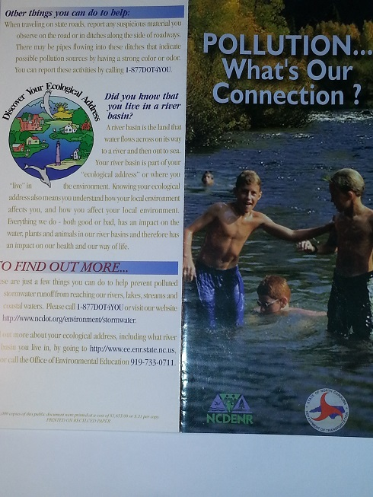
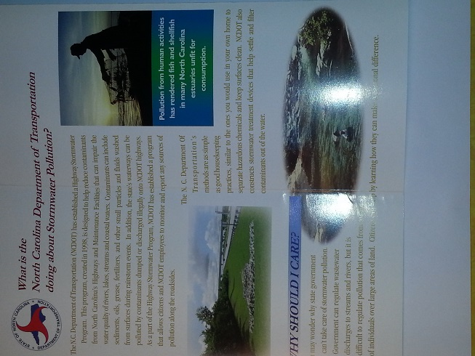
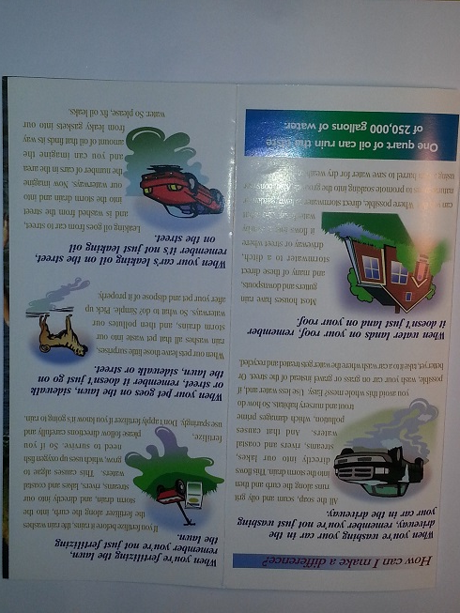
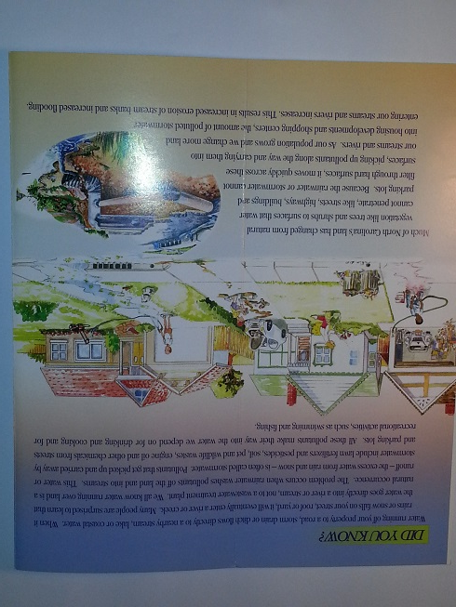

Drinking Water Treatment
PowerPoint slides from Drinking Treatment Water Seminar at Leesville Middle School by Joel Ducoste, Associate Professor at the Department of Civil, Construction, and Environmental Engineering

N.C. Environmental Education
http://www.ee.enr.state.nc.us/index.asp
Click on "North Carolina's Environmental Education". Select "Resources". Select "River Basin Program". Scroll down to "Discover NC's River Basin Booklet". Click on "Discover NC's River Basins". Scroll through the booklet skimming the text.

Quizlet Vocabulary Practice
http://www.quizlet.com/67026837/flashcards

References

1. http://www.newsobserver.com/2009/09/13/43848_clean-water-rules-ignored.html?rh=1
2. http://water.epa.gov/drink/contaminants/index.cfm
3.http://www.townofcary.org/Departments/townmanagersoffice/pio/News_Releases/news2013/psa_wqr.htm

4. Rawlins, Wade. "Neuse Ever Wary of ’95 Fish Kills." News&Observer [Raleigh] 11 Nov. 2005.

5. http://www.newsobserver.com/2009/09/19/92575/neuse-sees-biggest-fish-kill-in.html

6. https://www.youtube.com/watch?v=eHeUN6rr_us
7. http://portal.ncdenr.org/web/jordanlake/background

8. http://www.newsobserver.com/2013/12/14/3457928/with-jordan-lake-experiment-nc.html

9. http://news.nationalgeographic.com/news/2010/03/100310/why-tap-water-is-better/?rptregcta=reg_free_np&amp;rptregcampaign=20131016_rw_membership_n1p_us_ot_c1#finished

10. https://www.youtube.com/watch?v=9e5CaIkrqWU

11. http://www.newsobserver.com/2014/02/22/3643798_ash-spill-could-push-nc-to-move.html?rh=1

12. http://www.newsobserver.com/2014/01/31/3580905/35-million-gallons-of-sewage-spills.html

13. Rawlins, Wade. "Fishermen Alerted to PCBs: Lake Crabtree Posts Signs as EPA Probes Company." News & Observer [Raleigh] 21 May 2004.

14. http://www.newsobserver.com/2005/07/16/78755/state-crabtree-creek-fish-toxic.html

15. http://www.wsav.com/story/20949819/nbc-17-investigates-cleaning-up-toxic-mess-in-wake-forest-will-cost-taxpayers
16. http://www.newsobserver.com/2014/01/14/3532704/nc-fracking-panel-passes-chemical.html
17. http://www.newsobserver.com/2013/08/28/3145187/officials-ok-rule-to-force-fracking.html
18. http://www.newsobserver.com/2014/03/07/3683762/cuts-to-denr-regulators-jarring.html

19. Drinking Treatment Water Seminar at Leesville Middle School by Joel Ducoste, Associate Professor at the Department of Civil, Construction, and Environmental Engineering

20. http://www.ee.enr.state.nc.us/index.asp

21. http://www.quizlet.com/67026837/flashcards

Chapter 3. Water Quality

Monitoring Water Quality
What should you measure to determine the health of a stream or river? Physical factors include: water temperature, turbidity, and water movement.
We need to be aware of the contaminants in our water to ensure that our water is safe. The U.S. Environmental Protection Agency sets limits for water contaminants. These limits are considered to be the maximum safe level for each contaminant. Scientists measure physical, chemical and biological factors to determine water quality. Many of these factors can be measured with simple tests that can easily be used by students. Together the data from all of these tests determine the health of a waterway. In North Carolina, there is a program called Stream Watch that relies on students and other volunteers to collect and report water quality data from local streams and rivers.

Water Temperature
Water temperature determines the amount of oxygen and carbon dioxide that can dissolve in the water. Cold water holds more dissolved oxygen than warm water. The gills of aquatic animals such as fish and macroinvertebrates (organisms that lack a spine and are large enough to see with out magnification) extract the dissolved oxygen from the water. In late summer, when water temperatures are warm, large fish kills may occur due to low amounts of oxygen in the water. Different species of animals have evolved to survive in different water temperatures. Very warm water may not have enough oxygen for many species of animals.

Turbidity
Turbidity is the measure of the clarity (clearness) of water. Suspended solids such as soil particles from soil erosion and algae from excess nutrients reduce the clarity of water. Water with more suspended solids is less transparent. Water that contains high turbidity from organic pollution can contain pathogens. Suspended soil particles can clog the gills of aquatic insects (macroinvertebrates) and fish and smother animals that live on the bottom of a river or stream. Turbidity is measured with a Secchi disc or turbidity tube. Water that has a turbidity reading of <1 meter has a high concentration of suspended solids.
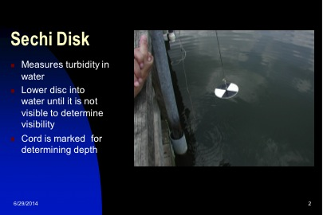
Figure 1. Photograph of a Sechi disk being used to measure water turbidity. Courtesy of Gail Powell.

Water Movement
Water Movement: Flowing waters capture air from the atmosphere and have higher concentrations of oxygen than still waters.

Dissolved oxygen (DO)
Chemical Factors: include dissolved oxygen, other gases, pH, nitrates, phosphates, and salinity.
Dissolved oxygen (DO): the concentration of oxygen dissolved in water; Oxygen comes from oxygen in the air and from photosynthesis by algae and plants. DO is important for the survival of zooplankton, macroinvertebrates and fish. Cold water holds more DO than warm water so DO varies with time of day and by season. Large fish kills are common in late summer and early fall due to low DO. 9-10 ppm is a very good level of DO. At <4 ppm some fish and macroinvertebrates die. Excess nutrients in water from sewage treatment plants, fertilizers, manure and leaking septic tanks lead to low DO. DO can be measured with an oxygen meter or with tablets from a water quality kit that cause the color of the water to change based on the concentration of the DO in the water.

pH
pH is a measure of how acidic or basic a substance is.
Every chemical has a pH. pH is measured on a scale of 0 to 14. pH = 7 is neutral; pH < 7 is an acid; pH > 7 is a base. Pure water has a pH of 7. A pH of 0 is a strong acid (high concentration of Hydrogen (H+) ions); pH 14 is a strong base (high concentration of hydroxide (OH-) ions). Strong acids and bases are harmful to the environment and human health.
pH is important because it controls many biological and chemical processes that occur in the water; Many plants and animals survive best in a limited range of pH. Changes in pH can kill these organisms. Acid rain caused by air pollution lowers the pH of streams, rivers and lakes. The pH of water determines the effect of other chemicals (ex: iron, aluminum, ammonia and mercury) on organisms. Acidic water makes some chemicals more poisonous. pH can be measured using pH paper or a pH meter.
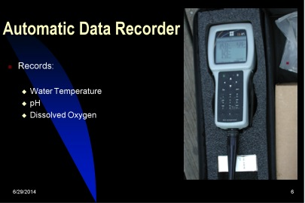
Figure 2. Photograph of an Automatic Data Recorder that can measure temperature, pH, and dissolved oxygen. Courtesy of Gail Powell.

Nitrates
Nitrates: Nitrogen is an essential plant nutrient. Nitrates get in water from surface water runoff that contains fertilizer, sewage, waste from leaking septic tanks, and erosion of some natural surfaces. Nitrates can cause eutrophication (excess growth of algae and low DO which can kill fish and macroinvertebrates);
Nitrate < 1ppm = excellent water quality; 1.1-3ppm = good, 3.1- 5 ppm = fair, > 5ppm = poor water quality.
Water quality test kits have simple color changing tablets or test strips that measure the nitrate concentration.

Phosphates
Phosphates: Phosphorous is an essential plant nutrient. Phosphate enters water from human and animal waste, laundry, cleaning and industrial waste. Phosphates like nitrates can also cause eutrophication.
Phosphate < 1 ppm = excellent, 1.1-4 ppm = good, 4.1 – 9.9 ppm = fair, > 10 = poor water quality.
Water quality test kits have simple color changing tablets or test strips that measure the phosphate concentration.

Salinity
Salinity: The concentration of dissolved salts. The concentration of salt in the ocean is 35 ppt. Most fresh water plants and animals have little tolerance for salt. In coastal areas, salt water can contaminate ground and surface water. In coastal communities, salt water can contaminate wells when communities over use ground water. As sea levels rise, fresh water ecosystems may become flooded with salt water.

Biological Factors:
bioindicators, macroinvertebrates, fecal coliform bacteria, Stream Index Value.

Fecal Coliform Bacteria
Fecal coliform bacteria are found in the feces of humans and animals; Their presence in water indicates that water has been contaminated with human waste or animal manure and may contain germs that cause human illness.

Bioindicators
Bioindicators: The presence, health, number of and types of fish, insects, algae, plants and other aquatic life “indicate” information about the health of a waterway.
Macroinvertebrates are important bioindicators of stream and river water quality. Macroinvertebrates are animals that lack a backbone (invertebrate) and are large enough to see with the naked eye. They include many types of immature aquatic insects, clams and worms. Certain types of macroinvertebrates can only live in clean water (Group1, Intolerant organisms). Other types can survive in moderately clean water (Group2, Semi-tolerant organisms). Some species can survive in very polluted water (Group3, Tolerant organisms). Macroinvertebrates live on the stream and river bottom. Scientists collect them using a kick net. Animals caught in the net are identified and counted. The type of animals found reveals the quality of the water in that stream.
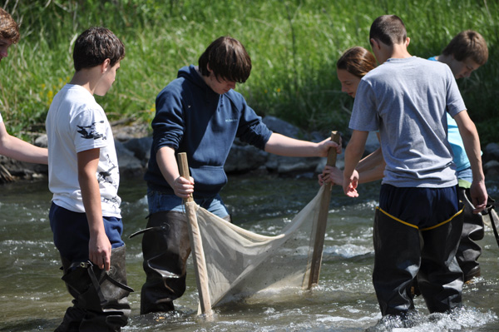
Figure 3. 8th grade science students from Camillus Middle School using a Kick Seine Net to collect aquatic macroinvertebrates. From http://www.extendonondaga.org/natural-resources/water-quality/stream-studies/

Stream Index Value (SIV)
Stream Index Value (SIV): Based on this data, a Stream Index Value (SIV) is calculated to determine the health of the stream or river. (Links to handouts: Sample Stream 1, Macroinvertebrate Identification Key, Aquatic Sampling.) The more types of animals found, (especially from Group 1 and 2), the cleaner the water in the stream. Healthy waterways have many different kinds of macroinvertebrates present. The SIV will be very high. If only a few types of macroinvertebrates are found and they are the types that can survive in polluted water, this tells us the water is polluted. The SIV will be low.

Using Stream Macroinvertebrates to Determine the Water Quality of a Stream
Activity
1. Examine the pictures of macroinvertebrates on the handout labeled “Sample Stream 1”.
2. Your teacher will instruct you on how to use the placemat size Macroinvertebrate Key to identify the organisms. (This tool is not in Simself.) After she has done this, use the key to identify each of the organisms in “Sample Stream 1”.
3. Assign each organism from Sample Stream 1 to a pollution category by Using the third handout “Macroinvertebrate Identification Key”.
4. Follow the directions on the sheet labeled “Aquatic Sampling to calculate the SIV “(1 to >23) and determine the Stream Index Rating (poor, fair, good, excellent) .
5. What can you tell me about the water quality of stream 1 based on this information?

Vocabulary words:
physical factors
biological factors
stream index value
chemical factors
nitrates
water quality
intolerant organisms
turbidity
bioindicators
eutrophication
dissolved oxygen
phosphates
monitoring water quality
tolerant organisms
water temperature
aquatic macroinvertebrates
fecal coliform bacteria
pH
salinity

Go to this link to practice these vocabulary words.
www.quizlet.com/67034607/flashcards Search for simselfch3gpowell.
You will take a vocabulary quiz when you are done.

Additional Resources
Sample Stream 1 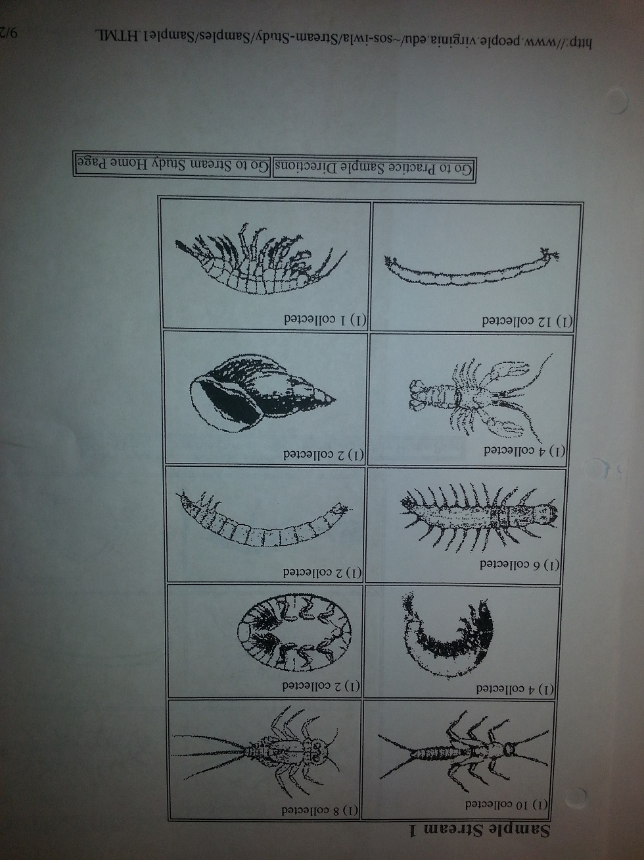
http:www.people.virginia.edu/~sos-iwla/stream-study/samples/sample1.HTML

Macroinvertebrate Identification Key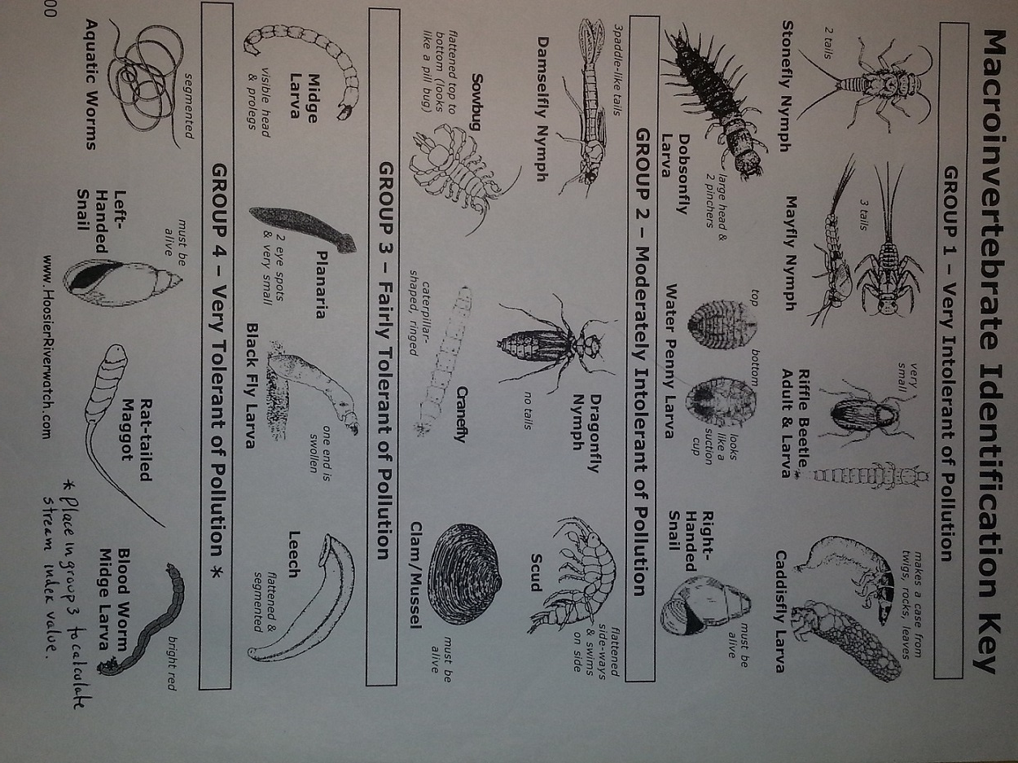
www.Hoosierriverwatch.com

Aquatic Sampling 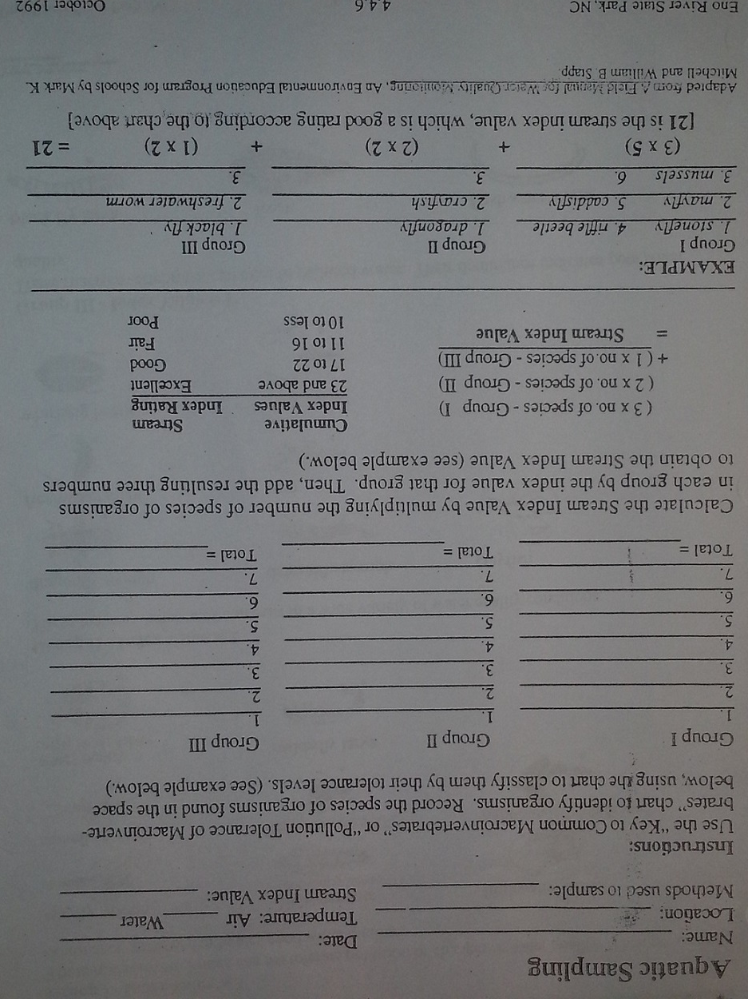
Eno River State Park, October 1992
References
1. http:www.people.virginia.edu/~sos-iwla/stream-study/samples/sample1.HTML
2. www.Hoosierriverwatch.com
3. Eno River State Park, October 1992
4. http://www.quizlet.com/67034607/flashcards

